**STAKEHOLDERS**

Passengers: These are the primary users of the system. Passengers use the system to search for flights, book tickets, check flight details, and manage their reservations.

Airline Staff: This includes the airline's employees who use the system to manage flight schedules, ticketing, and passenger information. They may include reservation agents, ticketing agents, and flight attendants.

Administrators: System administrators are responsible for the maintenance, security, and overall management of the system. They handle user accounts, database management, and ensure the system is functioning correctly.

Airline Management: This group includes higher-level executives and managers who use the system for decision-making, such as analyzing booking trends, monitoring revenue, and managing flight schedules.

IT Department: The IT department is responsible for the technical aspects of the system, including software development, server maintenance, and system updates.

Regulatory Authorities: Airlines are subject to various regulations and may need to provide information to regulatory authorities. These authorities may need access to the system for oversight and compliance.

Third-Party Vendors: If the airline management system integrates with third-party services (e.g., payment processors, booking engines, or data providers), these vendors are stakeholders as their services affect the system's functionality.

Marketing and Sales Teams: These teams use the system to promote flight offers, manage discounts, and analyze customer behavior to tailor marketing strategies.

Travel Agencies: If the airline collaborates with travel agencies, they might have access to the system to book flights on behalf of their clients.

Passenger Support and Customer Service: These teams use the system to assist passengers with booking, cancellations, and addressing issues or complaints.

Security Auditors: In the context of data security and compliance, security auditors may periodically assess the system to ensure it meets industry standards and is protected against security breaches.

Financial Departments: The finance team uses the system to track revenue, manage billing, and ensure financial transactions are accurate.

Competitors: Competing airlines may monitor the system to stay informed about pricing, flight schedules, and other competitive factors.

Investors and Shareholders: Individuals or organizations who have invested in the airline may be interested in how the system impacts the company's financial performance.

Government and Law Enforcement: In cases of security or legal issues, government agencies and law enforcement may need access to the system's data and records.

**USE CASE MODEL**

For the Airline Management System there are primarily two Users (Actors), the Passenger, which can search for flights etc. and the Administrator which manages the flights and Bookings etc. For each one we have different Use Cases :

**Passenger Use Cases:**

* Search Flights:

--Textual Description: The passenger can search for available flights based on criteria such as departure city, destination, date, and other preferences.

--The passenger provides search criteria, the system retrieves a list of available flights and the passenger views the list of flights.

* Book Flight:

--Textual Description: The passenger can book a flight by selecting a flight from the list, then it provides personal information and payment details, and the system confirms the booking and issues a ticket.

* Cancel Reservation:

--Textual Description: The passenger can cancel an existing flight reservation by logging into their account, then selects the reservation to cancel and the system cancels the reservation and processes any refunds.

**Administrator Use Cases:**

* Manage Bookings:

--Textual Description: The administrator can manage passenger bookings and reservation statuses by logging into the system, The administrator can view a list of passenger bookings and then can update reservation statuses (e.g., confirm, cancel, modify).

* Update Flight Information:

--Textual Description: The administrator can update flight details, such as schedules, availability, and pricing. The administrator logs into the system, then selects a flight to update and then can modify flight details.

* Manage User Accounts:

--Textual Description: The administrator can manage passenger user accounts. The administrator logs into the system then can view and manage user accounts (e.g., reset passwords, block accounts).

**GRAPHIC USE CASE MODEL**

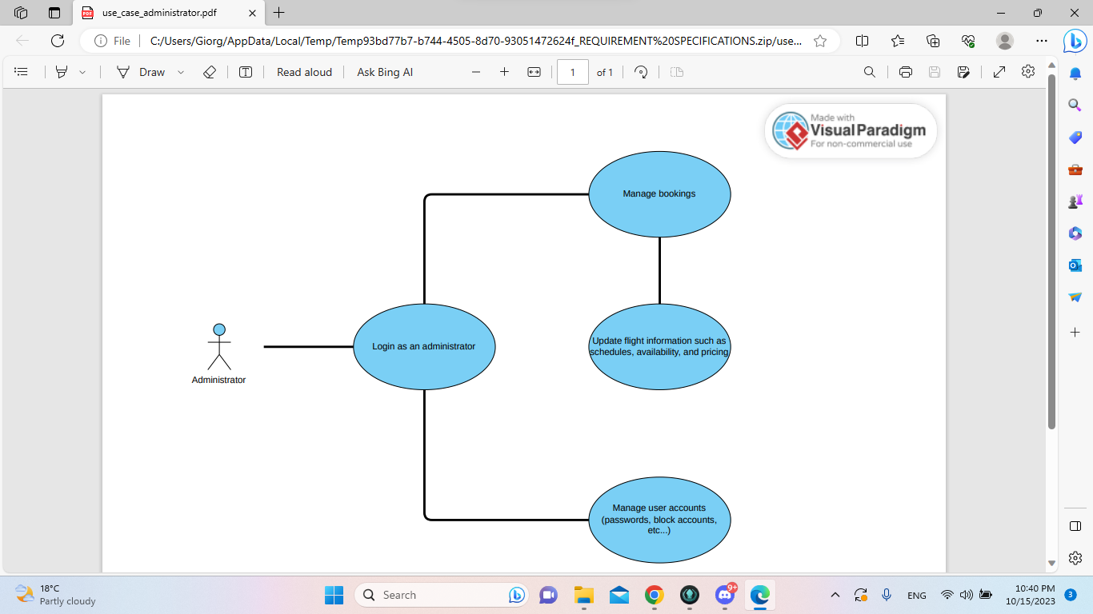

**RATIONALE**

* User-Centered Design:

The use case model is designed with a focus on the primary system users: passengers and administrators. Passengers can efficiently book flights, view flight availability, and cancel reservations, which enhances the user experience and reduces the need for offline booking counters.

* Efficient Booking Process:

Passengers can book flights online, reducing the need for physical visits to booking counters. This is not only convenient for passengers but also cost-effective for airlines, as it streamlines the booking process.

* Security and Authentication:

The "Authenticate User" use case ensures secure access to the system. It is essential for protecting passenger data and ensuring that only authorized personnel can manage the system.

* Flexibility and Accessibility:

The system is designed to be accessible from any location at any time, which aligns with modern passenger expectations. Passengers can view flight availability and make bookings whenever they want, enhancing the flexibility of the system.

* Administrator Control:

The "Manage Booking System" use case provides administrators with control over the system's core functionalities, such as flight availability and reservation management. This enables airlines to adapt to changing circumstances and efficiently allocate resources.

* Feedback Loop:

While not explicitly shown in the model, the system can incorporate a feedback loop where passengers can provide feedback on their experiences. This information can be used to continuously improve the system and the overall quality of service.

* Cost Savings and Operational Efficiency:

By reducing the need for offline booking counters, the system contributes to cost savings and enhances operational efficiency for the airline.

* Scalability:

The use case model is adaptable and scalable. As the airline business evolves and grows, additional use cases can be integrated into the system to meet new requirements without significantly altering the existing structure.

**NON-FUNCTIONAL REQUIREMENTS**

Performance:

* The system must support a minimum of 1000 concurrent users during peak hours.
* Response time for flight availability queries should be under 2 seconds.
* The system should handle at least 99% of transactions without errors.

Availability:

* The system should be available 24/7, with scheduled maintenance periods minimized.
* Availability should be at least 99.9%.

Reliability:

* The system should have a mean time between failures (MTBF) of at least 10,000 hours.
* In case of system failure, data integrity must be maintained, and transactions in progress should not be lost.

Security:

* User data and financial information must be encrypted and stored securely.
* Authentication and authorization mechanisms should be in place to prevent unauthorized access.
* The system should comply with industry security standards and regulations (e.g., GDPR, PCI DSS).

Scalability:

* The system must be scalable to accommodate increasing numbers of users and flights.
* Scalability should be achieved both horizontally and vertically.

Usability:

* The user interface should be intuitive and user-friendly to cater to users with various levels of technical expertise.
* Accessibility standards should be followed to ensure that the system can be used by individuals with disabilities.

Compatibility:

* The system should be compatible with a wide range of web browsers and devices.
* It should work on different operating systems.

Maintainability:

* The system should be easily maintainable, with the ability to update and patch software without significant downtime.
* Documentation for administrators and developers should be comprehensive.

Compliance:

* The system must adhere to aviation industry regulations and standards.
* It should also comply with data protection and privacy laws, such as GDPR.

Auditability:

* There should be a robust logging and audit trail system to track all user and administrator activities.
* The logs should be securely stored and tamper-evident.

Interoperability:

* The system should integrate with other airline systems, such as reservation systems, payment gateways, and flight tracking systems.

Data Backup and Recovery:

* Regular data backups must be performed, and there should be a disaster recovery plan in place to restore the system in case of data loss or catastrophic events.

Load Testing:

* Regular load testing should be conducted to ensure the system can handle the expected volume of transactions and users.

Geographic and Time Zone Considerations:

* The system should support different time zones, especially for international flights.
* It should provide localized content and language options for users in different regions.

Cost-effectiveness:

* The system should be cost-effective to develop, maintain, and operate, without incurring unnecessary expenses.